1. Creating and Renaming Files/Directories

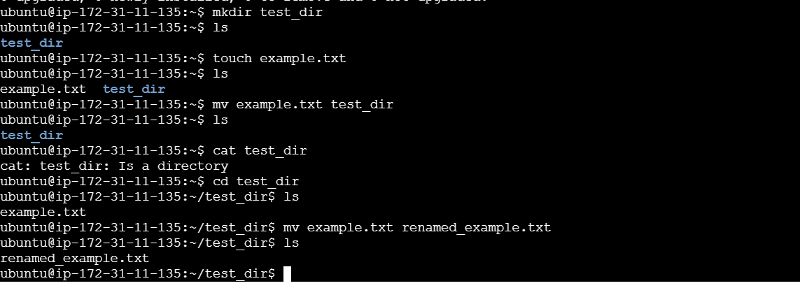

mkdir command is used to make directories and mv command is used to move or rename files or directories from one place to another

2. Viewing File Contents

Use cat to display the contents of /etc/passwd.

Display only the first 5 lines of /etc/passwd using head.

Display only the last 5 lines of /etc/passwd using tail.

cat /etc/passwd

Displays the entire contents of the /etc/passwd file, which stores user account information.

head -n 5 /etc/passwd

Displays the first 5 lines of /etc/passwd.

tail -n 5 /etc/passwd

Displays the last 5 lines of /etc/passwd

3.Searching for Patterns

Use grep to find all lines containing the word "root" in /etc/passwd.

grep "root" /etc/passwd

Searches for and displays all lines that contain the word "root".

4. Zipping and Unzipping

Compress the test_dir directory into a file named test_dir.zip using zip.

Unzip test_dir.zip into a new directory named unzipped_dir.

zip -r test_dir.zip test_dir

unzip test_dir.zip -d unzipped_dir

Compresses test_dir into test_dir.zip, then extracts it into unzipped_dir.

5. Downloading Files

Use wget to download a file from a URL (e.g., <https://example.com/sample.txt>).

Downloads a file from the internet to your current directory

6. Changing Permissions

Create a file named secure.txt and change its permissions to read-only for everyone using chmod.

chmod 444 secure.txt

It gives permission for read-only to everyone using chmod

7. Working with Environment Variables

Use export to set a new environment variable called MY_VAR with the value "Hello, Linux!".

export MY_VAR="Hello, Linux!"

echo $MY_VAR

Creates a new environment variable and displays its value.